Summer Nutrition Blog: Portion Sizes
It’s not just what you eat, but how much you eat that can help you maintain a healthy weight. Use our handy portion sizes to keep you looking and feeling great this summer.

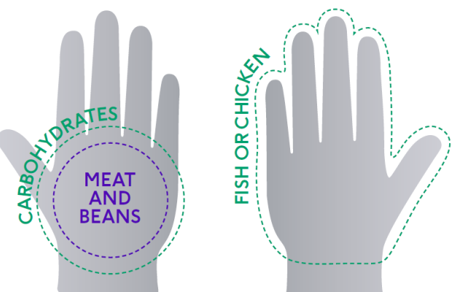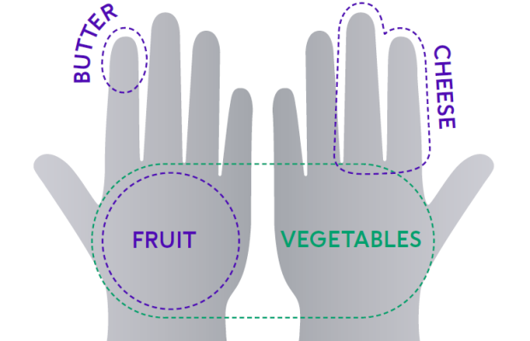

Here is our recipe of the month Tandoori salmon kebabs*
Ingredients:
- 2 x 115g (4oz) salmon steaks, skinned
- 3 small new potatoes
- Small piece fresh ginger, peeled and grated
- Finely grated zest and juice of ½ lime or lemon
Serves: 2 (Not suitable for home freezing)

Prep time: 15 minutes plus marinating time | Cooking time: 10 minutes
½ tsp ground turmeric

½ tsp garam masala

1 clove garlic, crushed

1 tbsp chopped fresh mint or coriander

4 tbsp fat-free Greek yoghurt
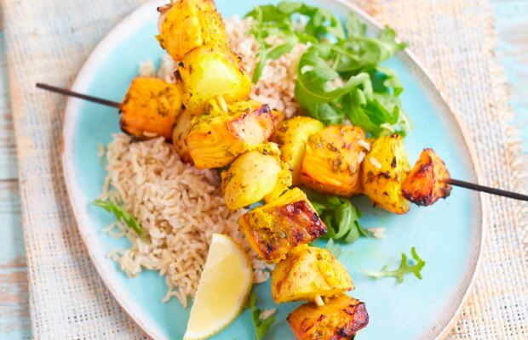
Method:
- Cut the salmon into large, bite-sized chunks. Steam or boil the potatoes until just tender then drain, cool and halve.
2. In a medium bowl, mix together the ginger, lemon, spices, garlic, mint and yoghurt. Stir in the fish and potatoes, cover and marinate in the fridge for at least one hour.
3. Thread the fish cubes and the potatoes onto wooden skewers and grill or barbecue for 3–5 minutes, turning until evenly browned.
4. Serve immediately with brown basmati rice, rocket or watercress, and lemon wedges.
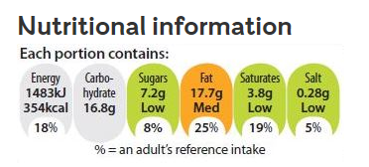
*Taken from British Heart Foundation https://www.bhf.org.uk/informationsupport/support/healthy-living/healthy-eating/recipe-finder/tandoori-salmon-kebabs

