Name: Click or tap here to enter text.
Address:Click or tap here to enter text.
Click or tap here to enter text.
Click or tap here to enter text.
Postcode:Click or tap here to enter text.
Email Address:Click or tap here to enter text.
Phone Number:Click or tap here to enter text.

Below is the plaque layout. Please enter the text in block capitals you would like on each line in the box on the right taking into account the maximum amount of Characters allowed per line. Please be mindful that spaces count as characters.
Click or tap here to enter text.
Click or tap here to enter text.
Click or tap here to enter text.
Click or tap here to enter text.
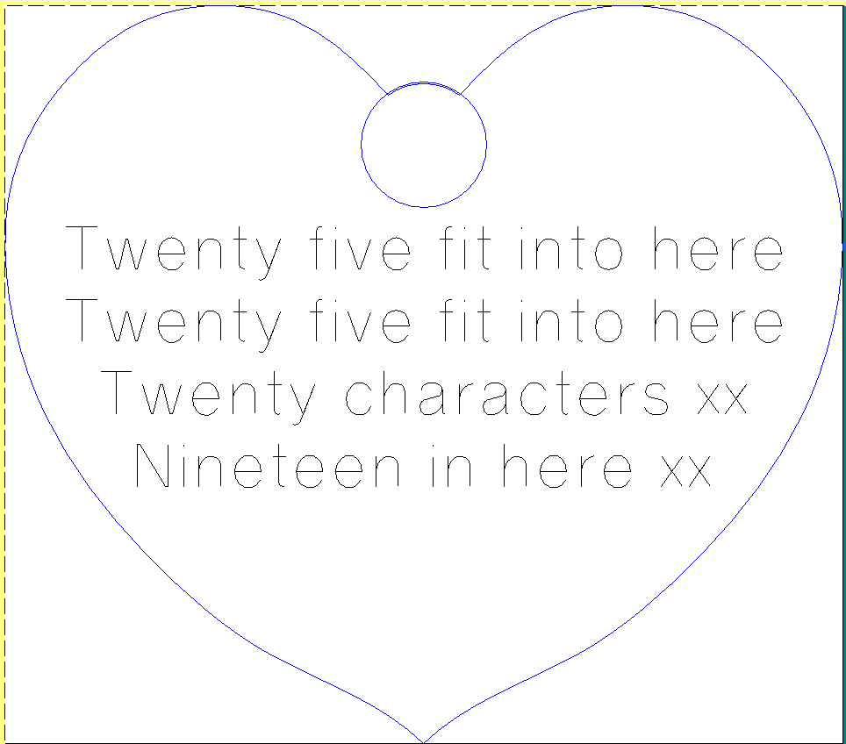
The cost of the plaque is £50 and will be displayed for 2 years from date the plaque is received from the Manufacturers. At the end of the 2 Years the plaque will be retuned to you.
Please return form by mail to Mrs L Ellis, New Start Charity, The Transplant Unit, Wythenshawe Hospital, Manchester M23 9LT with payment by Cheque made payable to Newstart or email to lyndaellis@newstartcharity.org.
Payment can also be made by BACS to Wythenshawe Hospital Transplant Fund, Account Number 71709917, sort code 40-08-22. Please put surname and "Tree" as reference.
Please indicate which method payment is made by:
Payment by Cheque ☐
Payment by BACS ☐
We are unable to engrave plaques until payment is made.

